Exno:5 b KVM – Create Images from ISO, Image Resizing, and Image Conversion

Date:

Aim:
To understand and demonstrate how to create virtual machine images
using ISO files, resize virtual disk images, and convert disk images between various formats.

Procedure:

Creating VM image from ISO

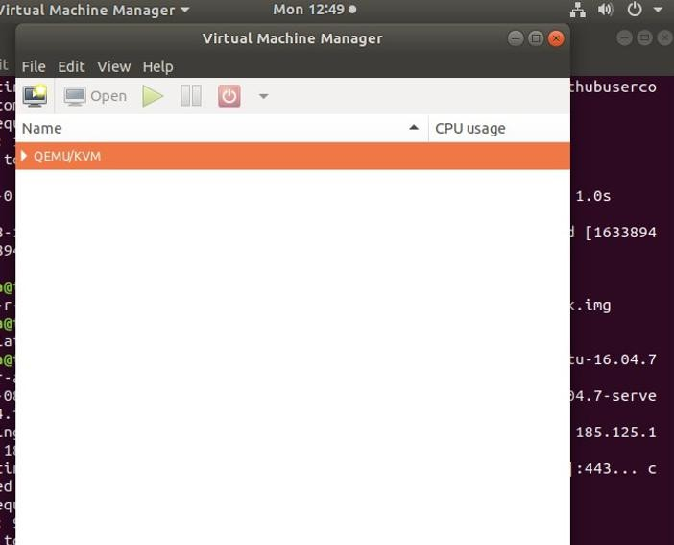
Go to virtual machine manager (virt-manager) in your linux system. Then, right click QEMU/KVM and select New to create new VM.

2 Select Local install media (ISO image or CDOM).
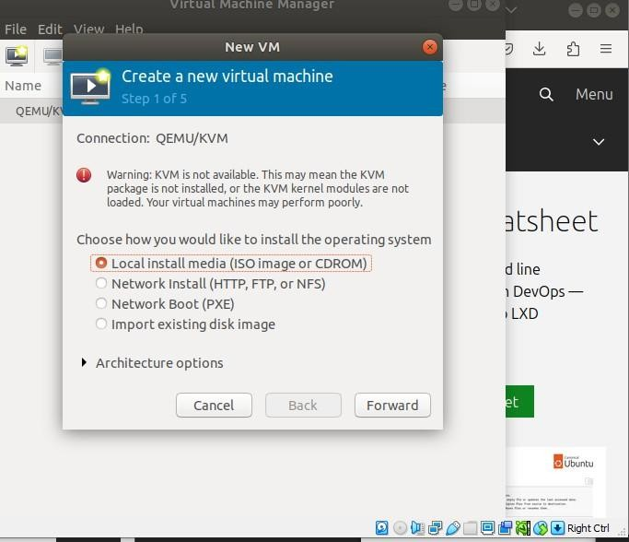

- Download ubuntu server iso from the link: https://releases.ubuntu.com/16.04/
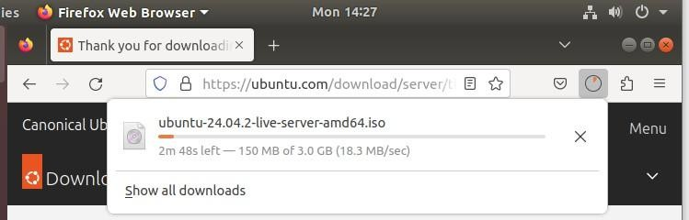

Select the downloaded ubuntu server iso path and click Forward.
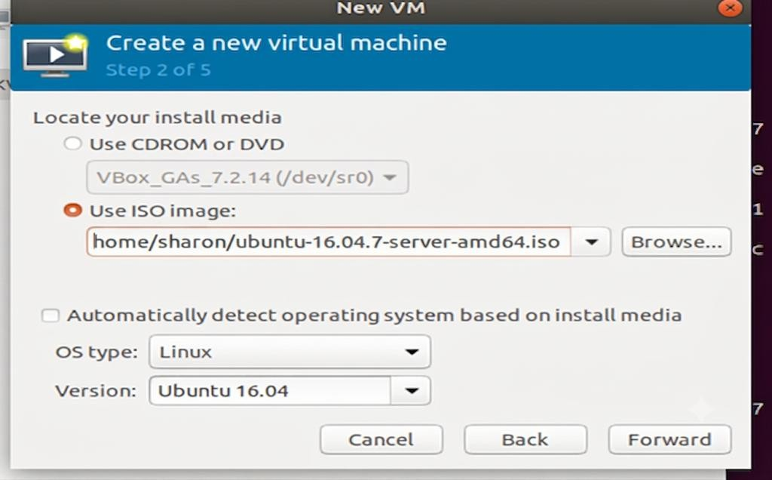

Specify the memory and CPU required and click Forward.
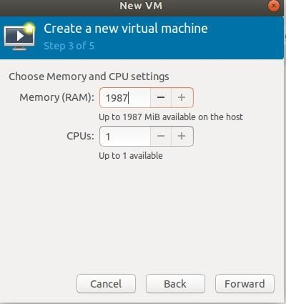

- Run the command : qemu-img create -f qcow2 ubuntu_vm.qcow2 10G

This command creates a virtual hard disk file (ubuntu_vm.qcow2) in the QCOW2 format, with a maximum size of 10 GB. This file will act as the virtual disk for a KVM virtual machine.

- Name the VM and click Finish.
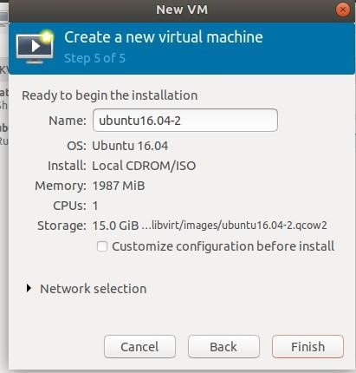

- Select the language.
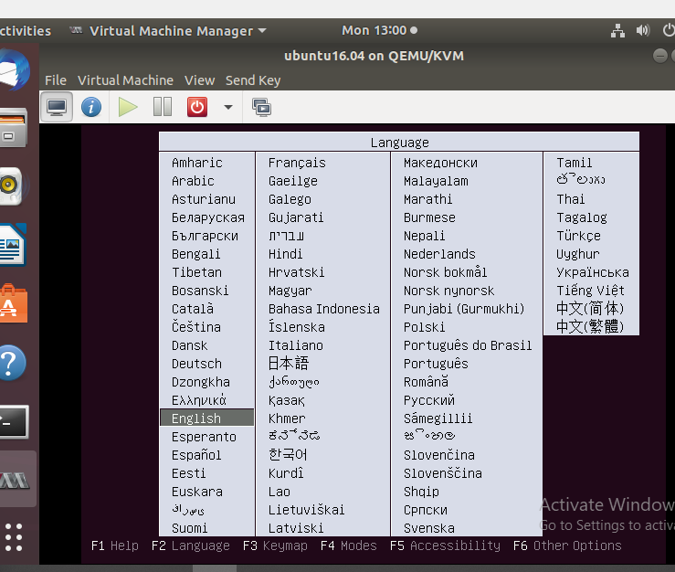

- Select Install Ubuntu Server and then the VM boots.
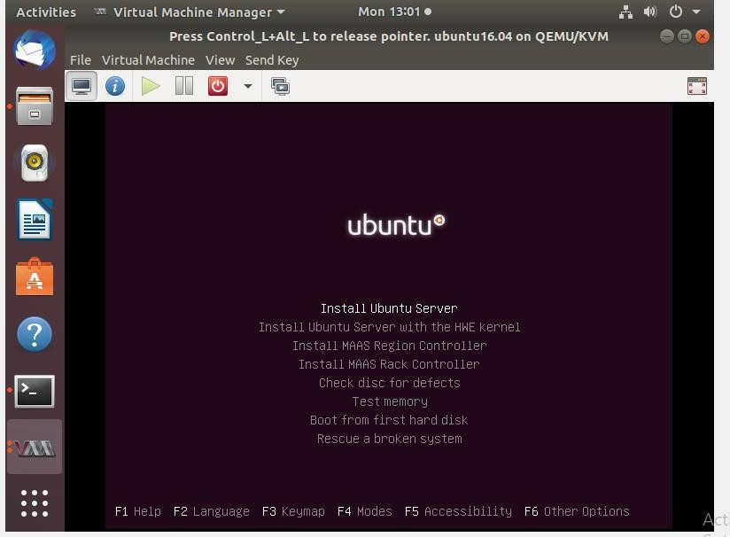

- Select the language and location.

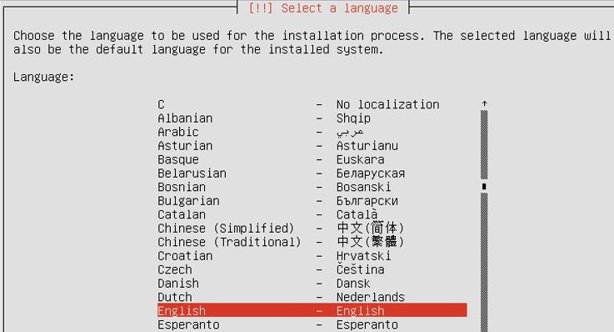

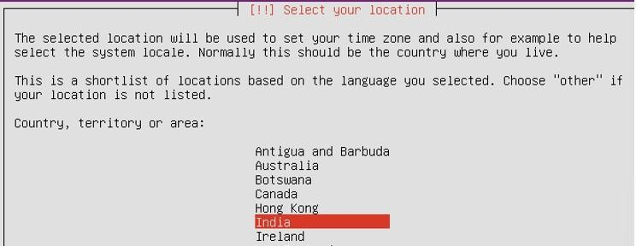

- Set the Keyboard configuration.
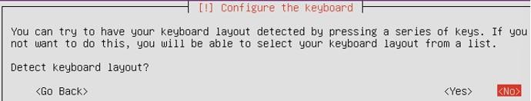

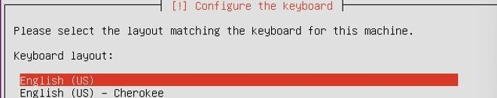

- Then it starts detecting, loading and scanning of needed things.

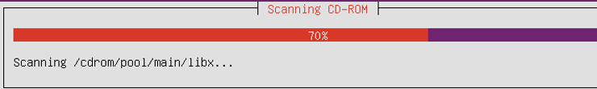

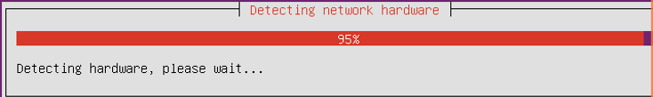

- Then set hostname, username, password and clock settings.
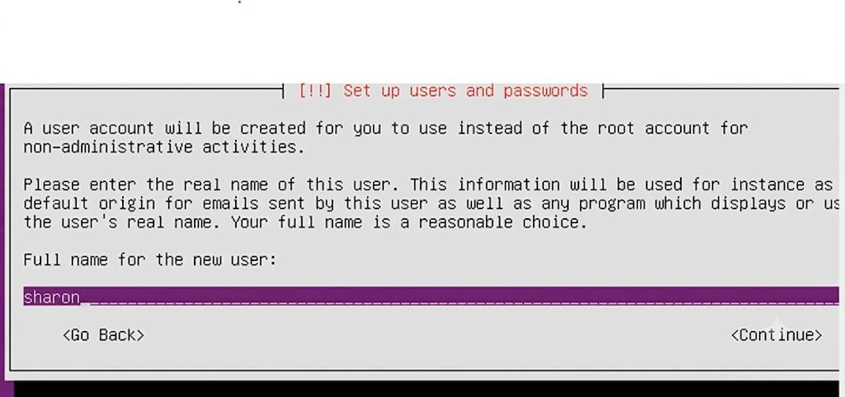

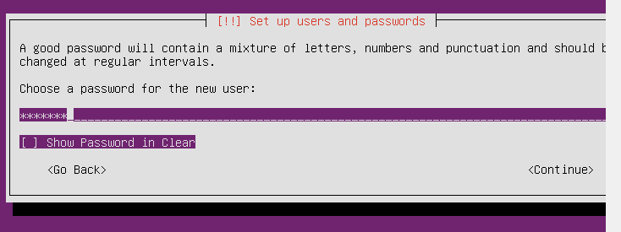

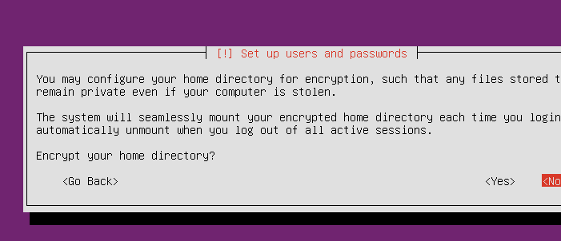

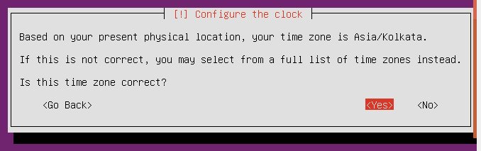

- Set the disk partition.

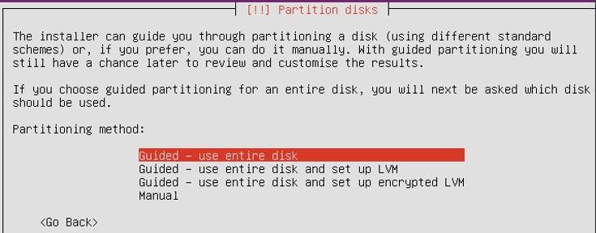

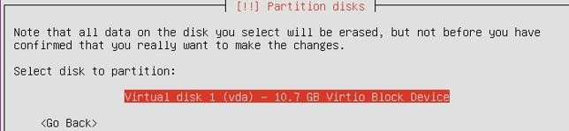

- Select Yes to write the changes to disks.

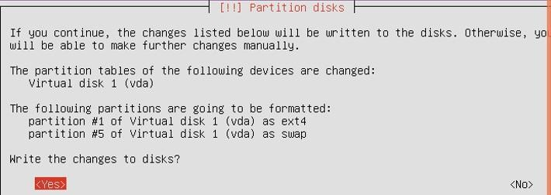

- Then, the system installation starts.

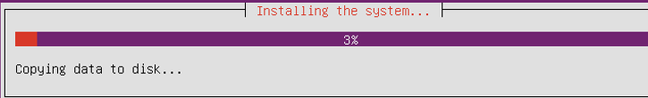
- For http proxy, just click Enter.
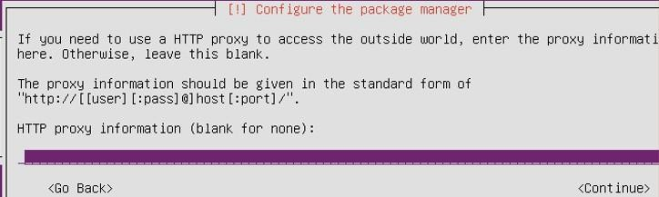

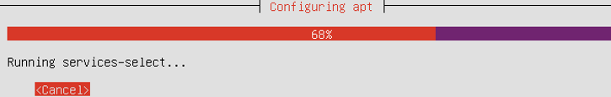

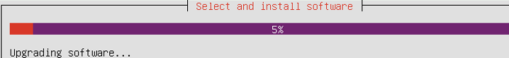

- Select No automatic updates option for configuring tasksel.
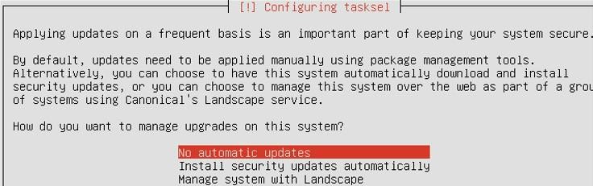

- In Software selection, select(use Spacebar) standard system utilities and OpenSSH server.
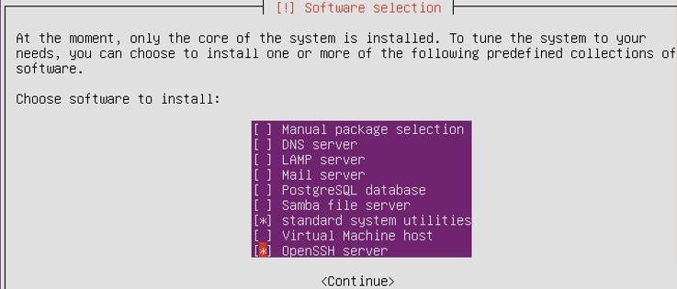

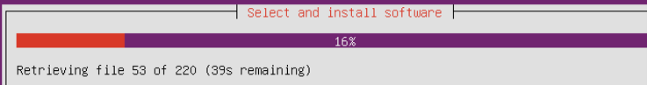

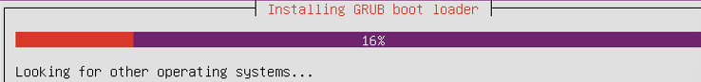

- Give Yes to install GRUB boot loader.
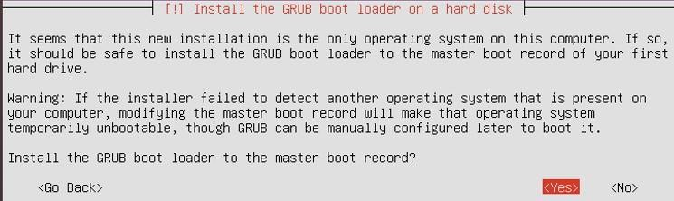
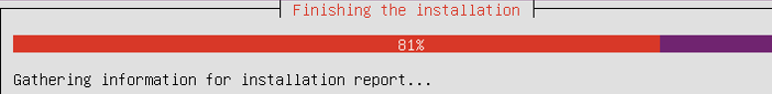

Image Resizing

- Shut down the VM if it's running.
- Resize the qcow2 image.

- Resize partitions inside the VM.

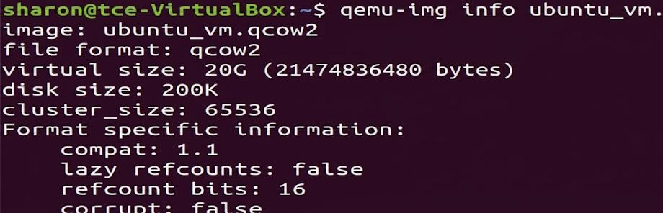

Once you've resized the image, boot into the VM and resize the partition/filesystem:
sudogrowpart /dev/sda 1 sudo resize2fs /dev/sda1

Image Conversion
- Conversion of qcow2 to vhd, vdi using qemu-img. qcow2 to vdi
qcow2 to vhd
qcow2 to img

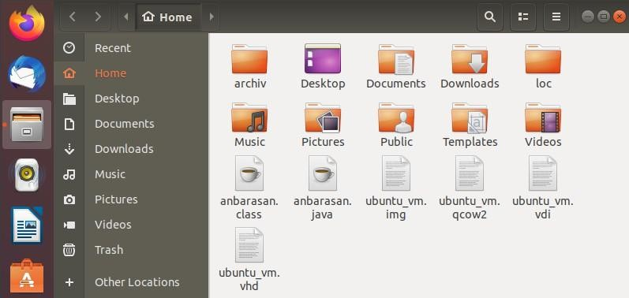

Result:
Thus, the creation, resizing, and format conversion of a KVM virtual disk image were successfully demonstrated.

